3.
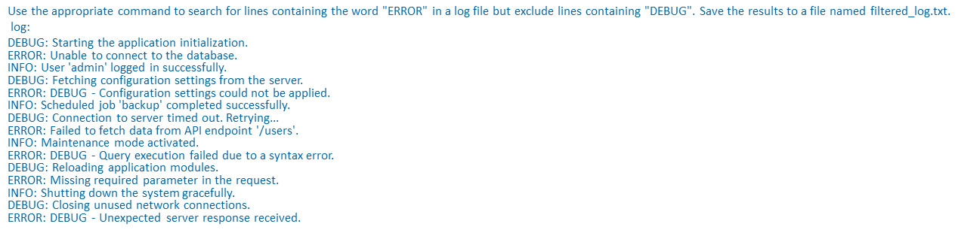

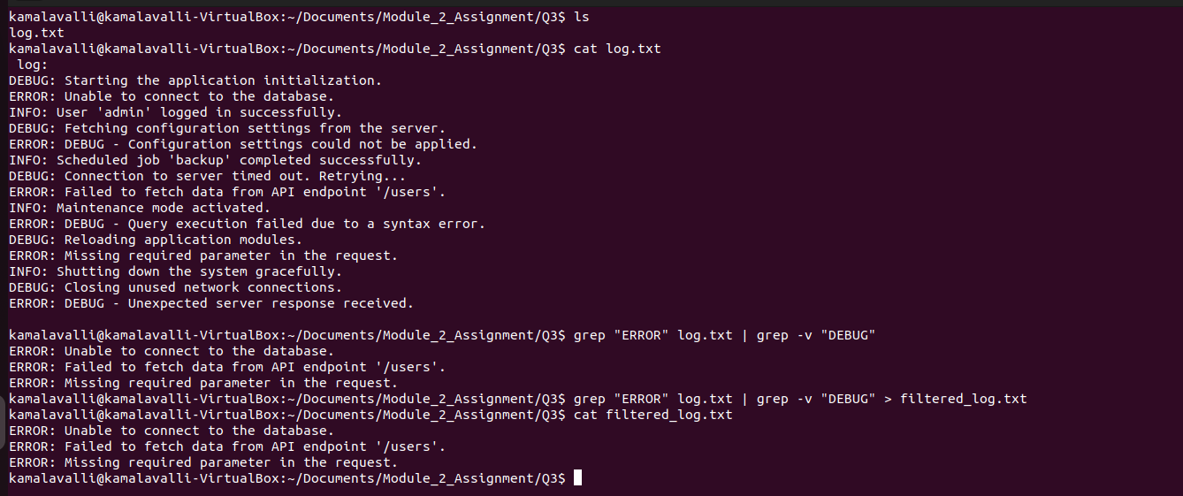
>> grep "ERROR" log.txt | grep -v "DEBUG" > filtered_log.txt

